HOW-TO record your paper as a presentation
You can record your presentation using your preferred software. Preferred options include Zoom recorded meeting or Microsoft Teams recorded meeting.
You may also use a PowerPoint presentation with recorded audio narration. However, please only use this option if you are unable to record a video.
We will accept a range of recording styles and video file (.mp4, m4a, .avi, etc.). However, in order to make the presentations engaging, consider a format that allows you to share slides and have the camera on. Please see below a screen shot example of the preferred layout for your presentation.
File size: Please make sure your individual presentations don’t exceed the 15 minute time limit and are not larger than 20 MB.
You can find an instruction guide on how to record using Zoom below. On page 2 you can find a guide for recording using Microsoft Teams.
Once you have recorded and saved your presentation, you can upload XXXXXXXX

Recording your Presentation via ZOOM

This video contains a step-by-step guide on how to record a presentation using Zoom:
https://www.youtube.com/watch?v=xHH5JEsa6B4
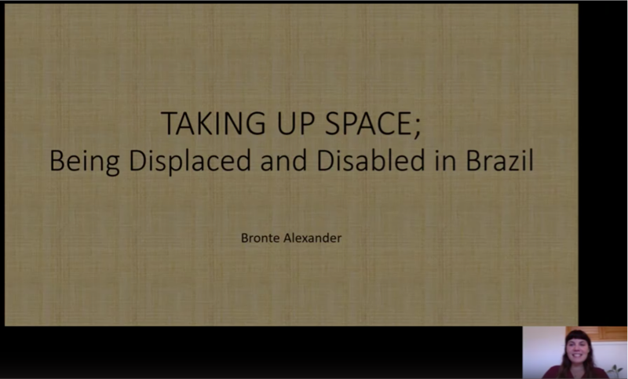
Recording your Presentation via Microsoft Teams
- Open the Microsoft Teams application on your device.
- Select Calendar > Meet Now
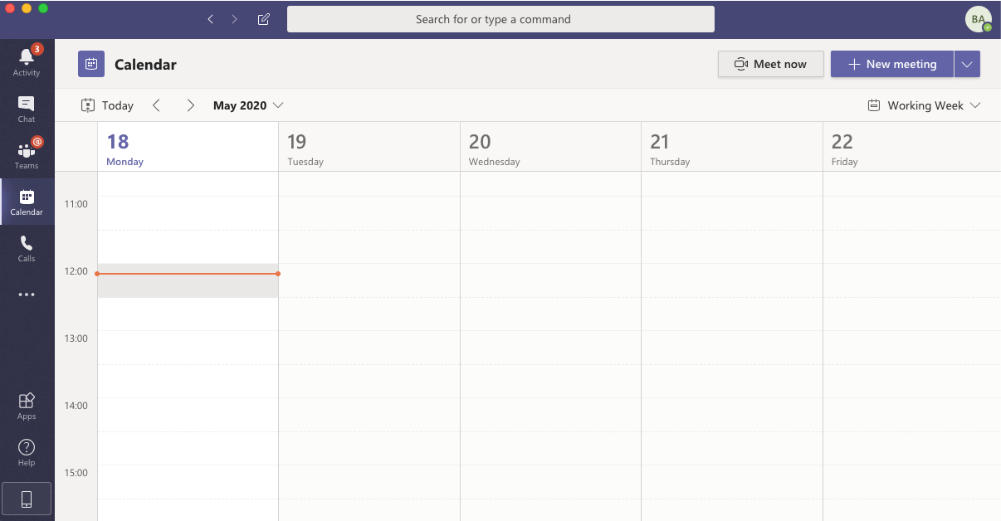
3. Change the meeting name to the title of your presentation
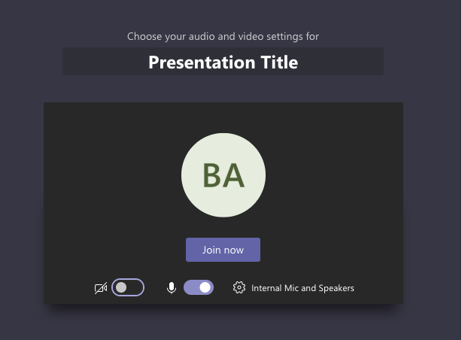

4. Share your screen and upload your PowerPoint presentation file 5. Make sure your webcam and microphone are working
6. Once you are ready to begin, select ‘start recording’
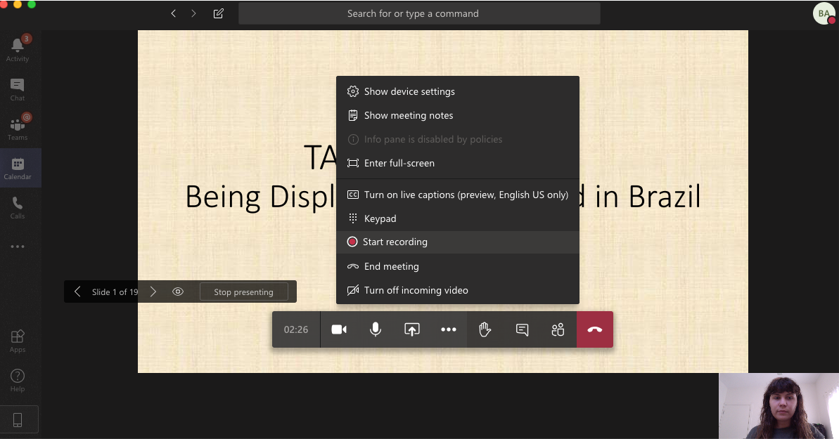
7. Speak to your presentation and navigate through the slides.
8. Once you are finished, select ‘stop recording’. You can now ‘hang up’ the meeting to
close the window.
When you have finished, you should receive an email providing a link to find your recorded presentation on Microsoft Stream. This may take some time to process depending on your internet connection. You can also find it by visiting the Stream website and logging in: https://www.microsoft.com/en-us/microsoft-365/microsoft-stream
9. Navigate to Microsoft Stream > My content > Videos
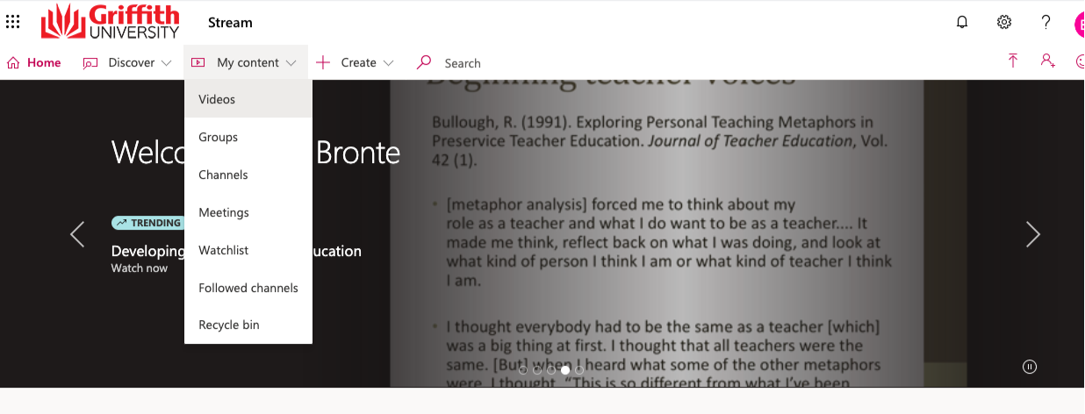

10. Select the video of your presentation > select ‘Download video’. It will save as an Mp4 file to your device.
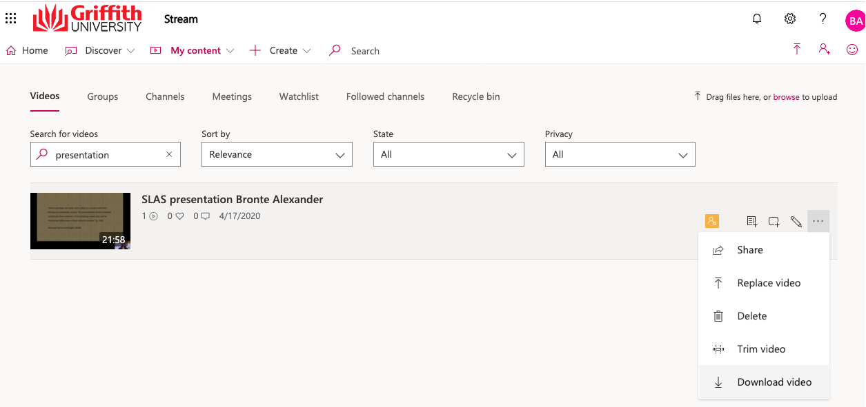
11. Finally, access the designated Microsoft Form (sent to you via email) to fill out your details and follow the instructions to upload your file.
Remember: If you are struggling to record your presentation in the right format or need assistance, please contact us at ailasa@ailasa.org with the subject line ‘Assistance for Paper Upload’. A member of the organising committee will set up a convenient time for a virtual meeting to assist you with the process before the conference start date.

